**SOLIDWORKS CLIENT INSTALLATION**

**For**

**SONA FOODS**

Date: **Dec 2019**

Author: **ASHVINI BADHE**

**DOCUMENT HISTORY**

| **Revision** | **Date** | **Created / Updated By** | **Description** | **Approved By** |
| --- | --- | --- | --- | --- |
| 1 | 02th Dec 2019 | Ashvini Badhe | First Draft | Ruturaj Purohit |
|  |  |  |  |  |

1. **PRE-REQUISITE**

SolidWorks should be installed on the client system.

1. **LAUNCH SWIMSETUP.BAT**

Run swimsetup.bat from Teamcenter_Integration_for_SolidWorks directory

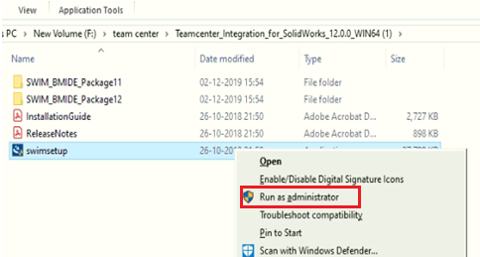

After launching the swimsetup.bat, ***Copyright Notice*** dialog is displayed. Click ***NEXT***

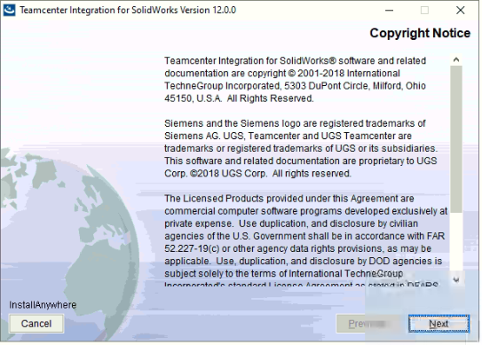

Click ***NEXT***

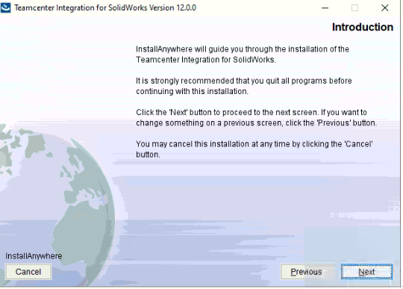

1. **SELECT TEAMCENTER VERSION**

Select ***Teamcenter 11*** radio button and click ***Next.***

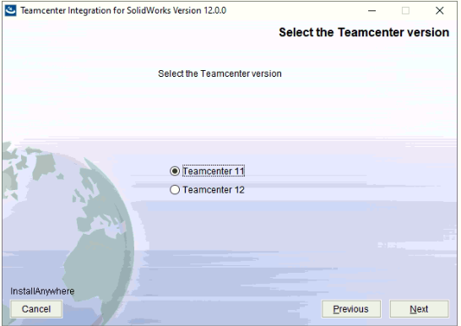

1. **SELECT LICENSE LEVEL**

Select ***Basic*** radio button and click ***Next.***

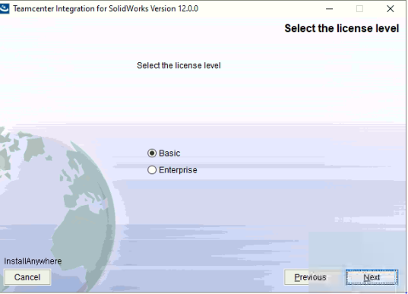

1. **INITIATE INSTALLATION**

Browse the location where the installation of SWIM should be carried out.

Browse location ***D:\team center\SWIM.*** Click ***Next.***

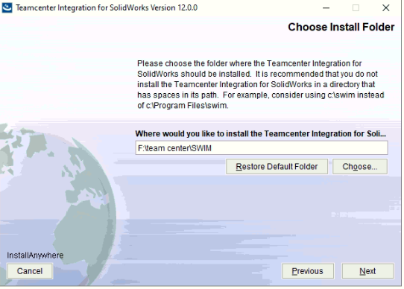

1. **CREATE SHORTCUT ICON FORINTEGRATOR**

Select ***On the Desktop*** radio button and click ***Next.***

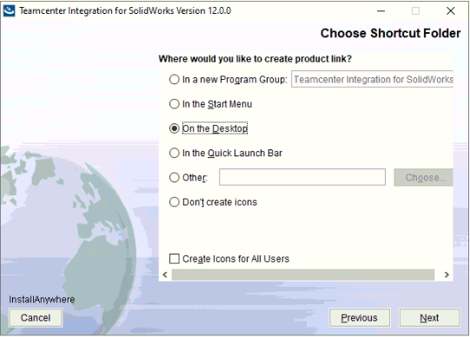

1. **SOLIDWORKS START FOLDER**

Browse the location where the create shortcut icon for integrator should be carried out.

Browse location ***C:\Users\Abhishek\Desktop.*** Click ***Next.***

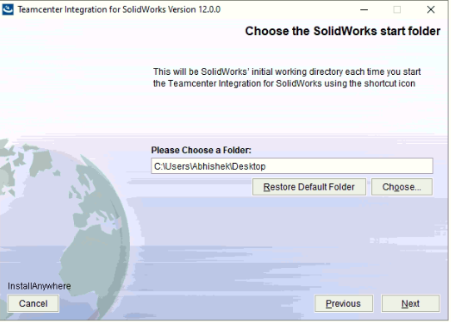

1. **TEAMCENTER CLIENT CONNECTION**

Select ***Teamcenter Rich Client*** radio button and click ***Next.***

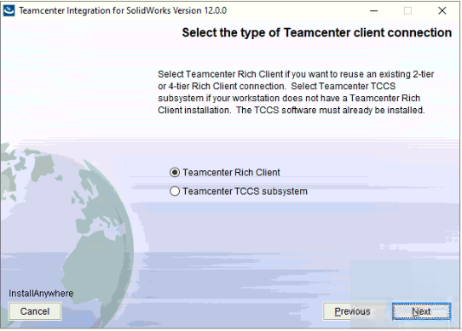

1. **RICH CLIENT INSTALLATION FOLDER**

Browse the location where the Rich client already installed.

Browse location ***C:\Program Files\Siemens\TEAMCENTER\4TClient\portal.*** Click ***Next.***

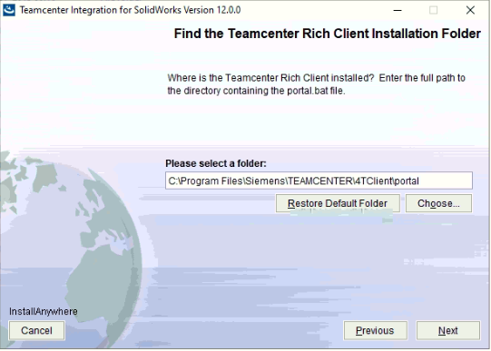

1. **TCCS INSTALLATION DIRECTORY**

Click ***Next.***

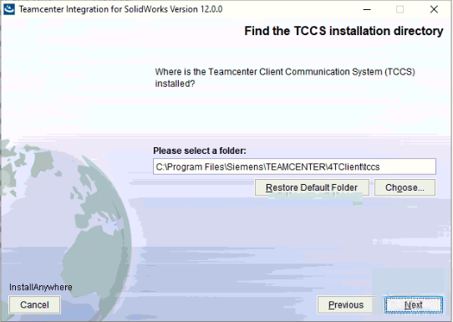

1. **JRE DIRECTORY**

Click ***Next.***

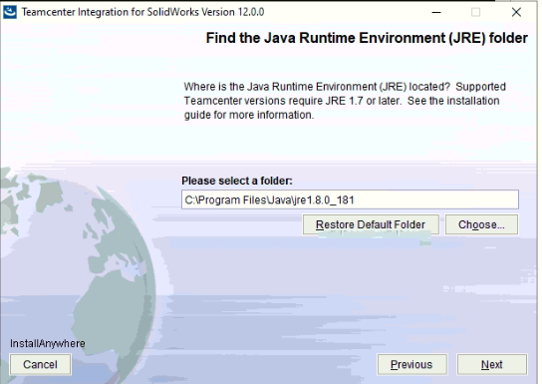

1. **CONFIGURE JT TRANSLATION**

Select ***Generate and Save*** radio button and click ***Next.***

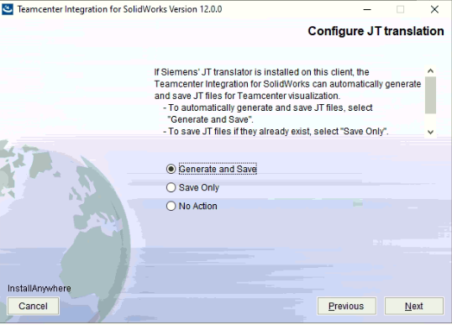

1. **JT TRANSLATOR DIRECTORY**

Browse the location where the installation of JT Translator should be carried out.

Browse location ***F:\team center\JT TRANSLATOR DIRECTORY.*** Click ***Next.***

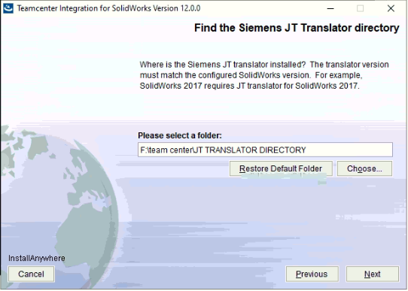

1. **CHECK FOR JT TRANSLATOR FOLDER**

Click ***Continue.***

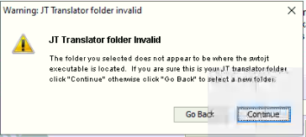

1. **CONFIGURE SOLIDWORKS TOOLBOX MANAGEMENT**

Click Next.

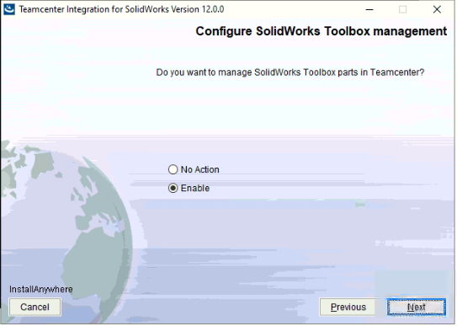

1. **SOLIDWORKS TOOLBOX DIRECTORY**

Browse the location where the Solidwork Toolbox already located

Browse location ***F:\SOLIDWORKS 2018 SP04\Toolbox.*** Click ***Next.***

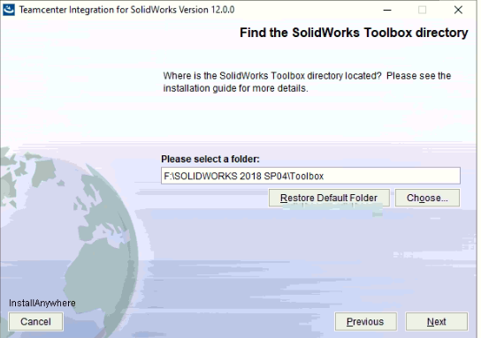

1. **CHECK FOR TOOLBOX DIRECTORY**

Click ***Continue***

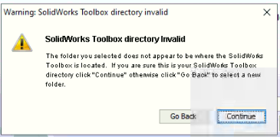

1. **TEAMCENTER MULTI-SITE**

Click ***Next.***

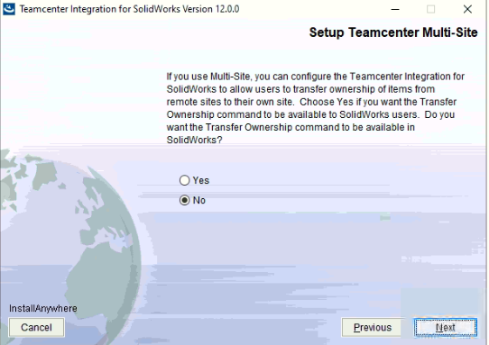

1. **CONFIRMATION**

Validate all the details entered and click on ***Install.***

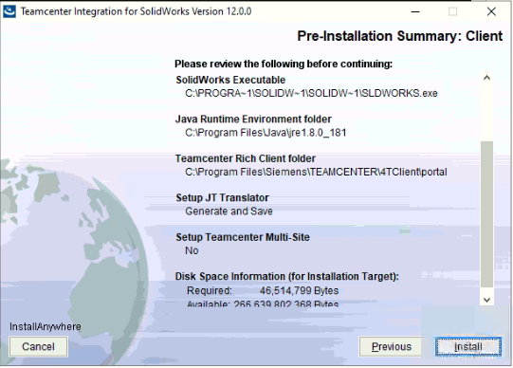

1. **INSTALLATION PROGRESS**

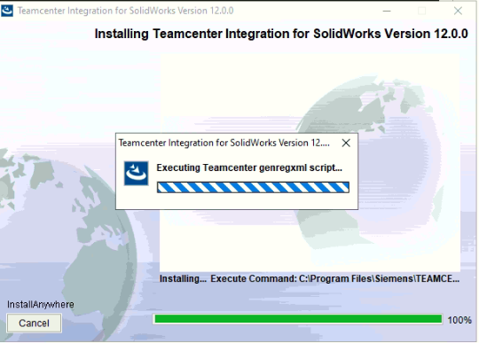

1. **ADDITIONAL CONFIGURATION**

Click ***Next.***

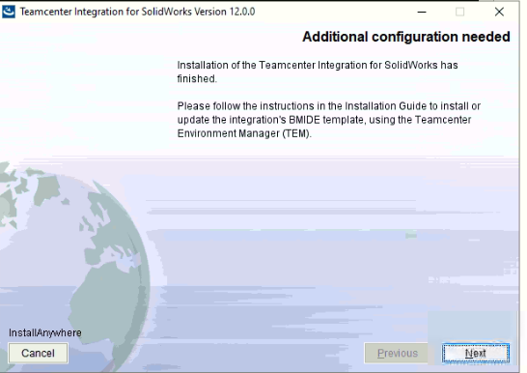

1. **INSTALLATION COMPLETE**

Click ***Done.***

